23I0544

MUHAMMAD HAMMAD

BCS-3D

TASK 01:  
CPP

#include <stdio.h>

extern "C" void ThreeProd();

int main()

{

int num1, num2, num3, rslt;

printf("Enter three numbers: ");

scanf_s("%d %d %d", &num1, &num2, &num3);

_asm

{

mov eax,num1

mov ebx,num2

mov ecx, num3

call ThreeProd

mov rslt, eax ; Store result from eax into rslt

}

printf("\nSource result = %d\n\n", rslt);

return 0;

}

ASM:

.686

.MODEL FLAT, C

.STACK 2048

.DATA

.CODE

ThreeProd PROC

comment!

pop ecx

pop ebx

pop eax!

imul eax, ebx

imul eax, ecx

ret

ThreeProd ENDP

END

OUTPUT  
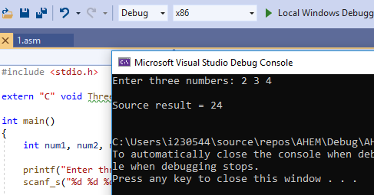

TASK02:  
CPP:

#include <stdio.h>

extern "C" void GCD();

int main()

{

int num1, num2, rslt;

printf("Enter two numbers: ");

scanf_s("%d %d", &num1, &num2);

_asm

{

mov eax, num1

mov ebx, num2

call GCD

mov rslt, eax

}

printf("\nSource result = %d\n\n", rslt);

return 0;

}

ASM:

#include <stdio.h>

extern "C" void GCD();

int main()

{

int num1, num2, rslt;

printf("Enter two numbers: ");

scanf_s("%d %d", &num1, &num2);

_asm

{

mov eax, num1

mov ebx, num2

call GCD

mov rslt, eax

}

printf("\nSource result = %d\n\n", rslt);

return 0;

}

OUTPUT:

